1. Which are the top three variables in your model that contribute most towards the probability of a lead getting converted?

**Solution:**

The below screenshot gives us the key features that play a significant role in the lead conversion rate.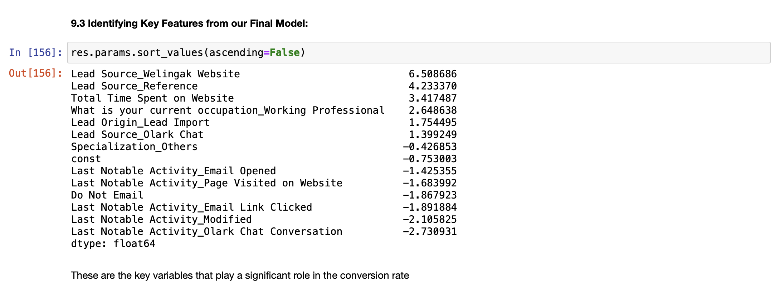

From the above screenshot, The top three variables that contribute towards the probability of a lead getting converted are:

1. **Lead Source_Welingak Website**
2. **Lead Source_Reference**
3. **Total Time Spent on Website**
4. What are the top 3 categorical/dummy variables in the model which should be focused the most on in order to increase the probability of lead conversion?

**Solution:**

The top 3 categorical/dummy variables in the model which should be focused the most on in order to increase the probability of lead conversion are:

1. **Lead Source_Welingak Website**
2. **Lead Source_Reference**
3. **What is your current occupation_Working Professional**
4. X Education has a period of 2 months every year during which they hire some interns. The sales team, in particular, has around 10 interns allotted to them. So during this phase, they wish to make the lead conversion more aggressive. So they want almost all of the potential leads (i.e. the customers who have been predicted as 1 by the model) to be converted and hence, want to make phone calls to as much of such people as possible. Suggest a good strategy they should employ at this stage.

**Solution:**

To intensify lead conversion efforts and maximize the capture of potential leads, X Education should opt for a **lower probability threshold**. This approach prioritizes achieving a high level of sensitivity, which ensures the correct identification of almost all leads with a likelihood to convert.

However, it's crucial to recognize that there may be instances where non-conversion cases are inadvertently classified as conversions.

Nonetheless, this approach equips agents with the means to proactively connect with a wider range of potential leads, substantially **enhancing the likelihood of successful conversions.**

With two months and 10 interns, the company should target all potential leads, focusing on those with lower conversion probabilities to **boost overall conversion rates.**

| **Features** | **Correlation With Lead Conversion** |
| --- | --- |
| Lead Source_Welingak Website | 6.508686 |
| Lead Source_Reference | 4.233370 |
| Total Time Spent on Website | 3.417487 |
| What is your current occupation_Working Professional | 2.648638 |
| Lead Origin_Lead Import | 1.754495 |
| Lead Source_Olark Chat | 1.399249 |
| Specialization_Others | -0.426853 |
| const | -0.753003 |
| Last Notable Activity_Email Opened | -1.425355 |
| Last Notable Activity_Page Visited on Website | -1.683992 |
| Do Not Email | -1.867923 |
| Last Notable Activity_Email Link Clicked | -1.891884 |
| Last Notable Activity_Modified | -2.105825 |
| Last Notable Activity_Olark Chat Conversation | -2.730931 |

The company needs to focus on the customers from the following:

1. **Last Notable Activity_Olark Chat Conversation**
2. **Last Notable Activity_Modified**
3. **Last Notable Activity_Email Link Clicked**
4. **Do Not Email**
5. **Last Notable Activity_Page Visited on Website**
6. **Last Notable Activity_Email Opened**
7. **Specialization_Others**
8. **Lead Source_Olark Chat**
9. **Lead Origin_Lead Import**
10. **What is your current occupation_Working Professional**
11. Similarly, at times, the company reaches its target for a quarter before the deadline. During this time, the company wants the sales team to focus on some new work as well. So during this time, the company’s aim is to not make phone calls unless it’s extremely necessary, i.e. they want to minimize the rate of useless phone calls. Suggest a strategy they should employ at this stage.

**Solution:**

During the **critical quarter** leading up to the deadline, the company faces a limited timeframe. Therefore, it is paramount to direct efforts toward **hot leads** with the highest lead conversion rates. To optimize efficiency, the company should prioritize these leads, primarily based on their lead score. Specifically, targeting leads with a **lead score** exceeding **85% is essential**.

In this scenario, the company should shift its focus towards alternative methods such as **automated emails** and **SMS**. By doing so, excessive calling can be minimized unless there's an emergency. This strategy is best employed with customers who exhibit a significantly **high likelihood of course purchase**.